**SOFTWARE DEVELOPMENT LABORATORY**

**EXPERIMENT: 1**

**CREATE THE PRODUCT BACKLOG**

**AIM:**

To create a product backlog using Monday.com that contains all the ideas and work items that might be used into the product over time.

**PROCEDURE:**

1. In the Monday.com website sign up with email and password and create the project with the necessary details.
2. Enter project title and enter the team members who are all going to work under the project.
3. Choose the domain of the project as educational research .
4. Invite the team members to the project by sending the invitation through the email.
5. The workspace will be appeared with the projects needed details.

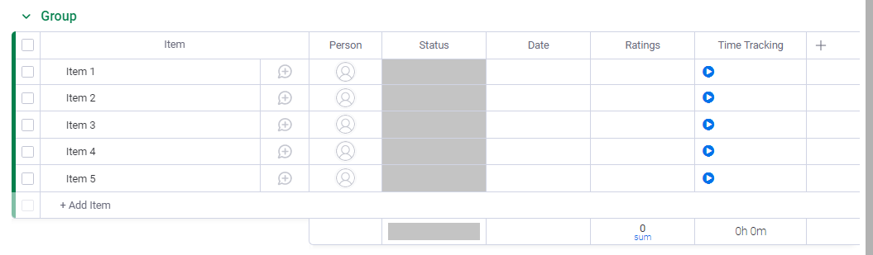

1. The team members can be viewed in the panel.

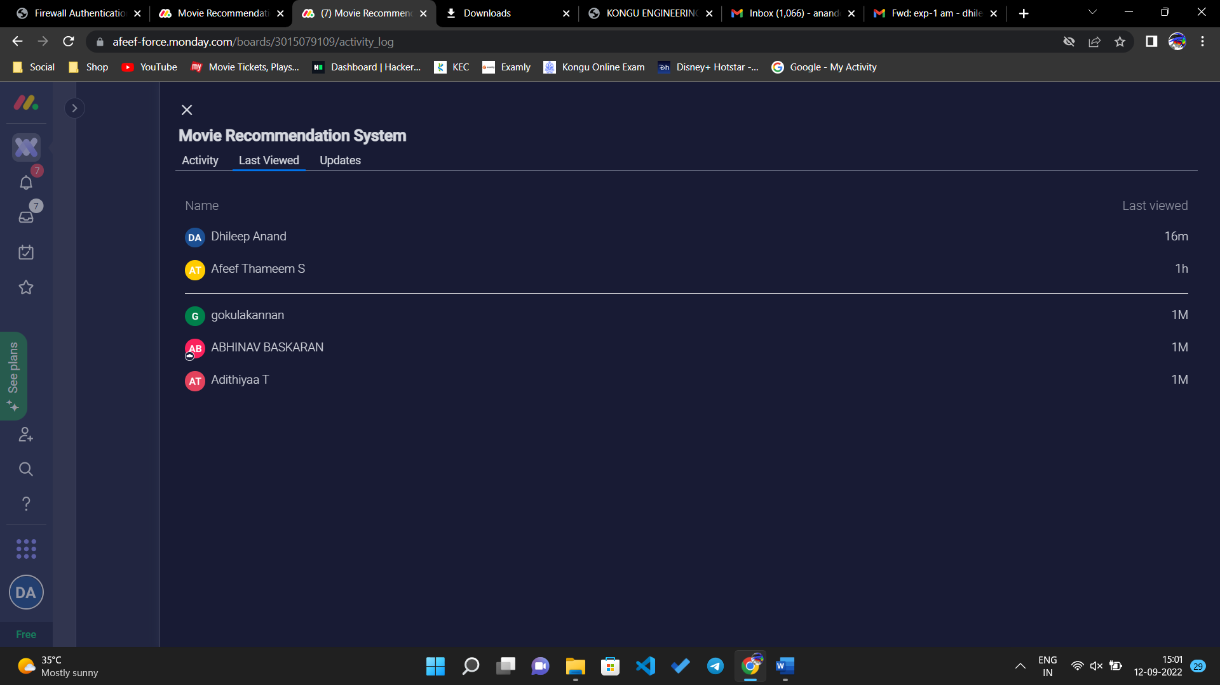

1. The ideas to complete the project can be edited and the persons can be allotted.

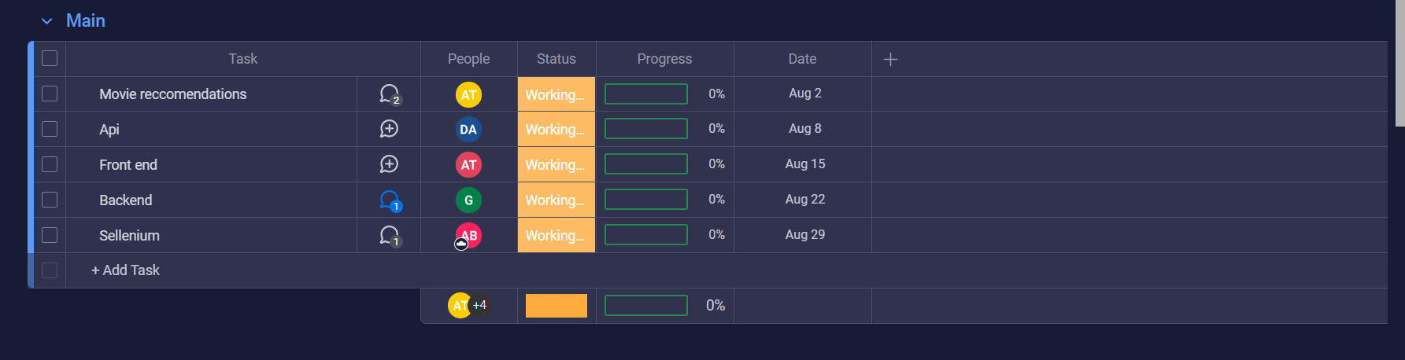

1. Through the activity log all the team members can view each other’s work progress.

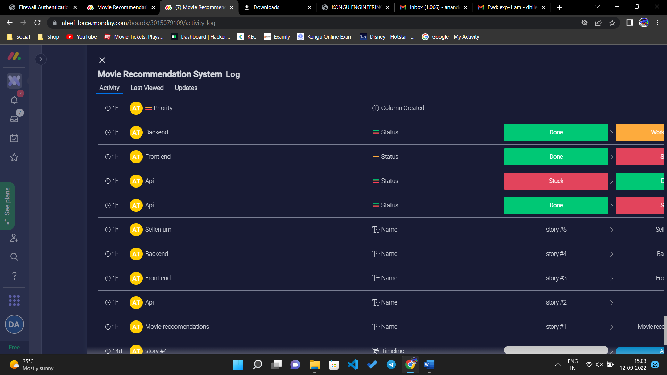

1. The deadlines to finish the work can also be mentioned in the task page.
2. Save all the work and discuss with the team members.

**RESULT:**

Thus, the product backlog can be created with Monday.com and the work ideas are discussed with team members.